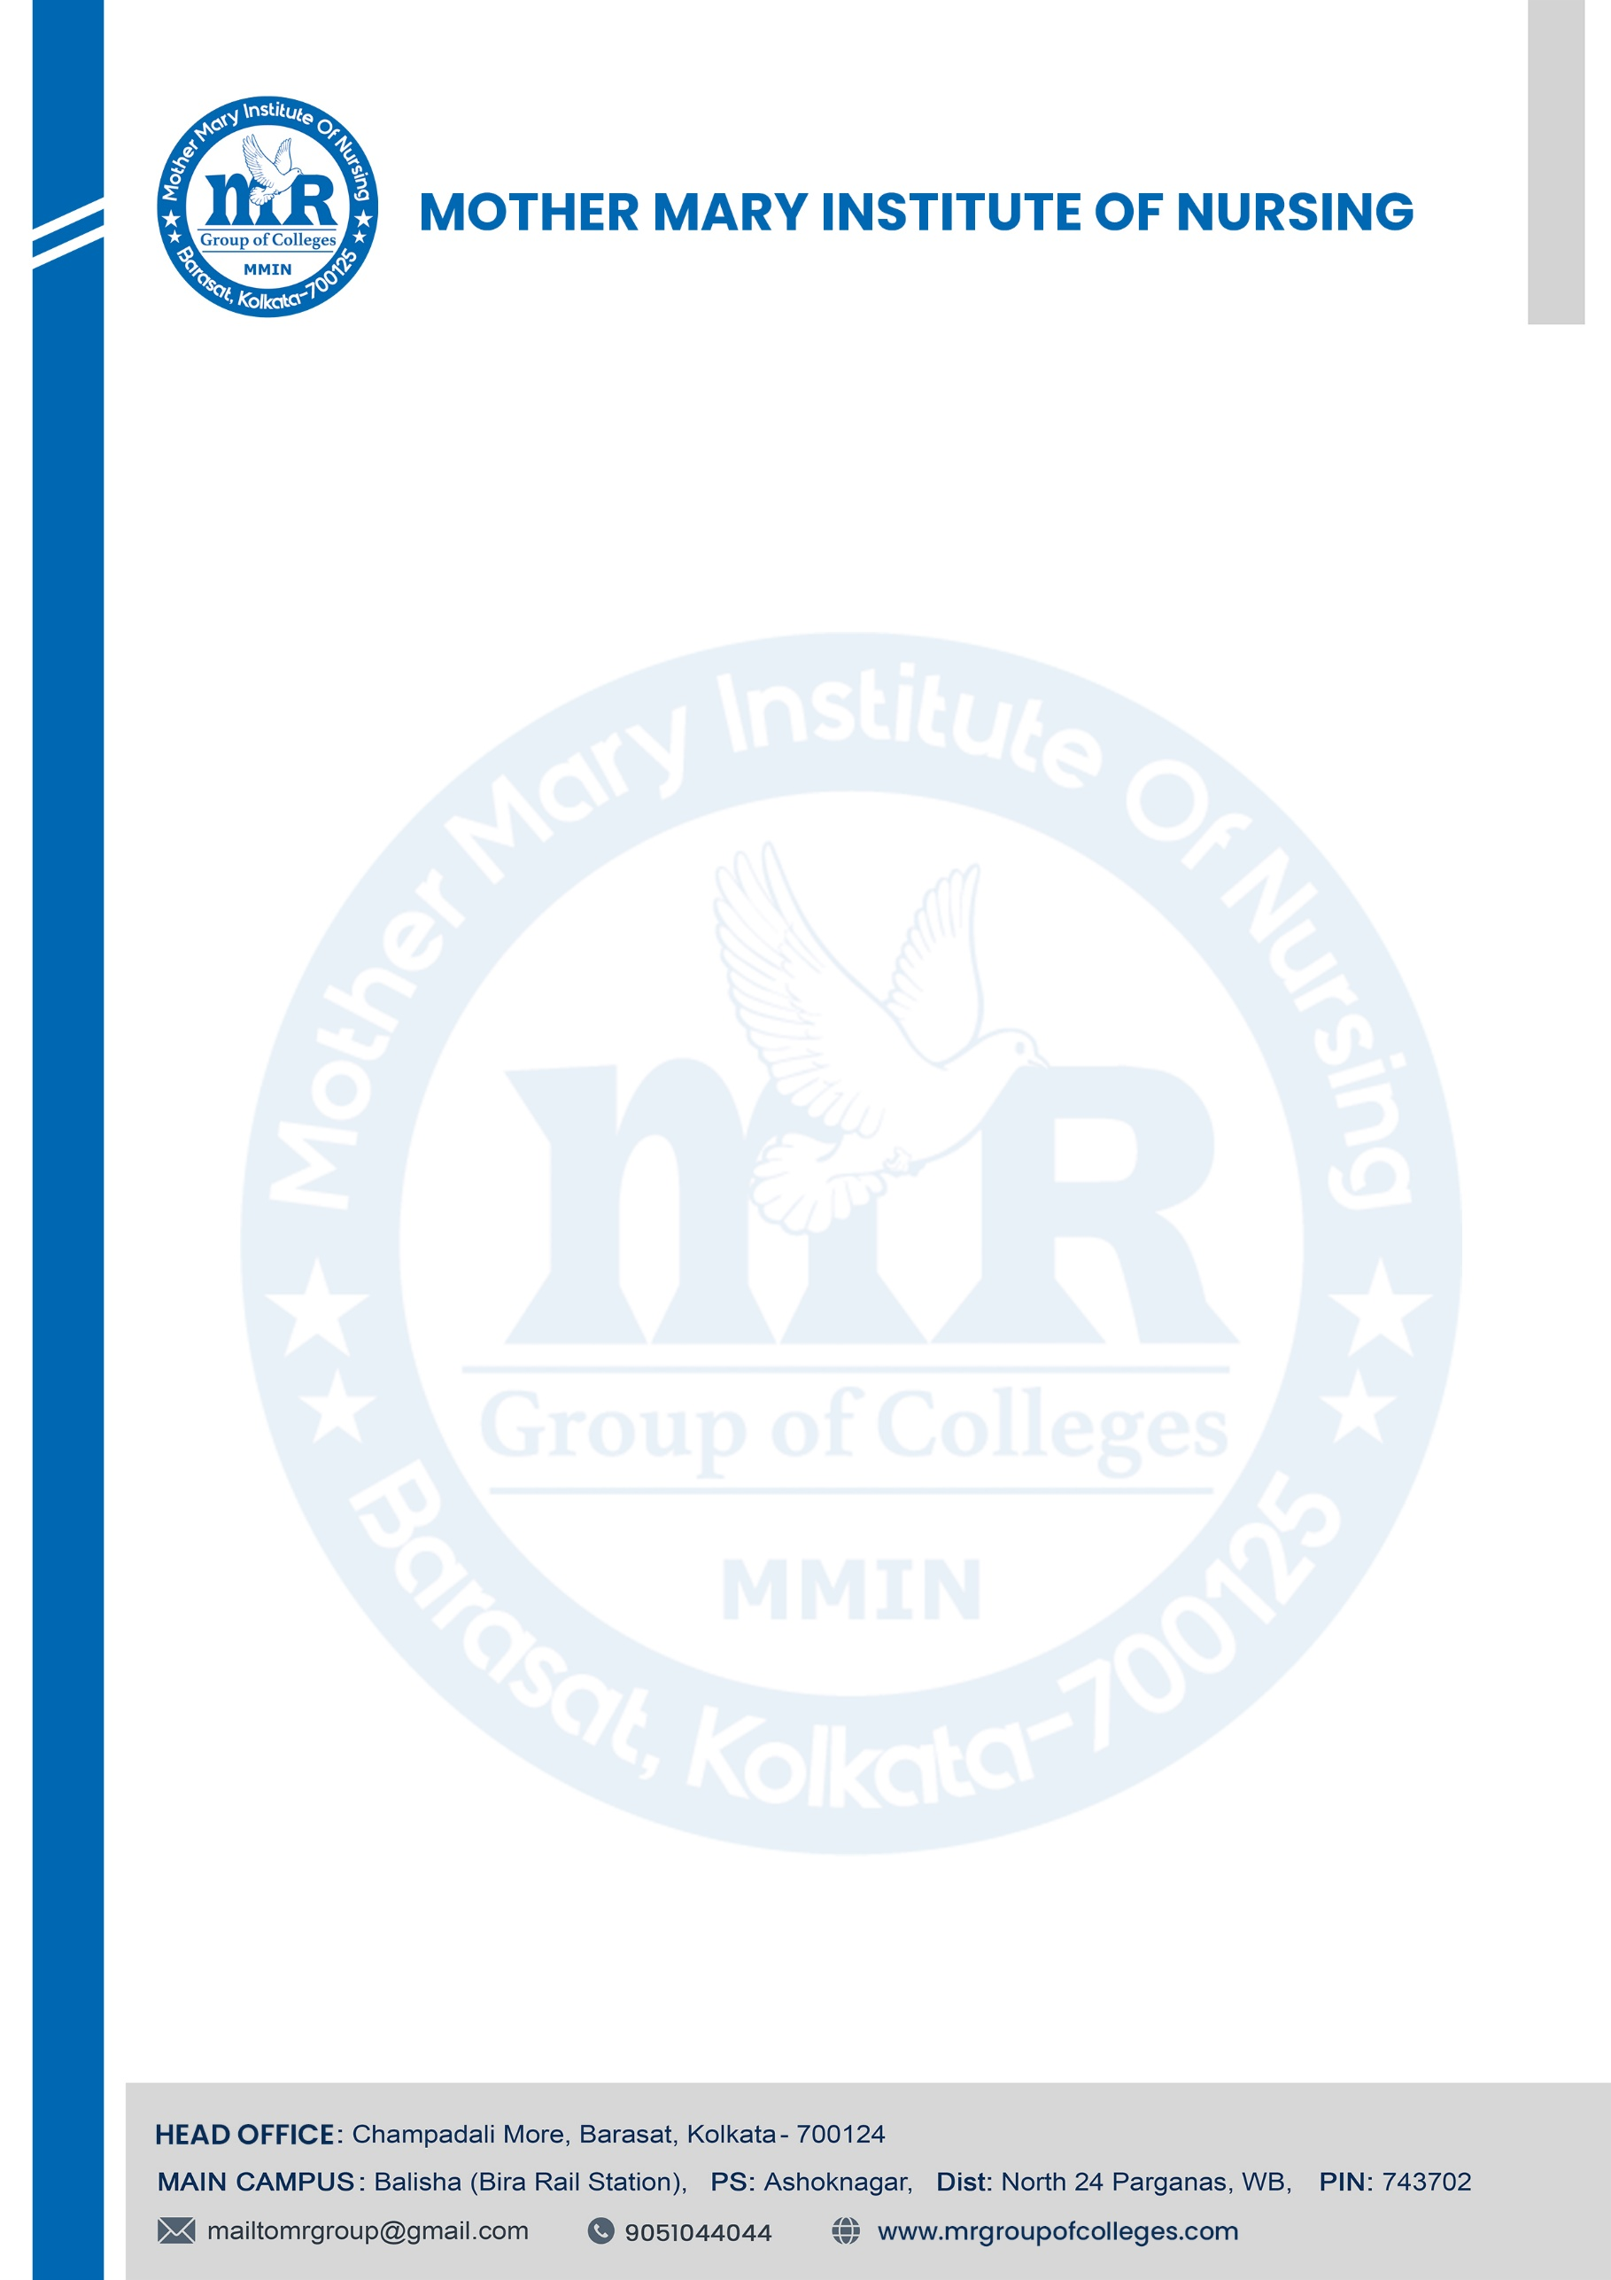

Date –

ADMISSION CONFIRMATION LETTER

This is to certify that Miss. Suparna Mondal, daughter of Mr. Ramsankar Mondal, has been admitted to the GNM Nursing Course at our institution for the academic session 2024-2027. Her admission has been granted under a merit seat as per the guidelines and permission of the Department of Health and Family Welfare, Government of West Bengal, and the norms set by the West Bengal Nursing Council and the Indian Nursing Council.

Course Fee Structure:
The total fee for the entire four-years GNM Nursing Course program is Rs. 6,00,000/- (Rupees Six Lakhs Only), payable as per the following schedule:

FEES STRUCTURE Academic Session - 2024-2027
Particulars | Admission | 1st Semester | 2nd Semester | 3rd Semester | 4th Semester | 5th Semester | 6th Semester | 7th Semester | 8 th Semester
Admission Fees
Tuition Fees
Equipment & Computer
Book & Stationery
Others Fees Payable to Institute
Hostel
Total
GRAND TOTAL



Additional Charges:
- Dress/Uniform Charges: Not included in the above fee.
- Books and Study Materials: To be purchased separately.
- Examination Fees: Excluded and to be paid as applicable.

Eligibility: 10+2 any discipline, aggregate 40%(English Mandatory), WBJEE Entrance Examination Rank Card (Mandatory).
Seat booking amount: Rs. 20,000/- (non-refundable). This amount will be adjusted against the admission fee.

Regards,



Date:

To,
The Branch Managers,
All Branches of All Banks
Subject: Placement Record and Institutional Updates
Respected Sir/Madam,
With due respect, I would like to inform you that Mother Mary Institute of Nursing has obtained NOC, Recognition, Affiliation, and Suitability from the Government of West Bengal, West Bengal Nursing Council (WBNC), West Bengal University of Health Sciences (WBUHS), and Indian Nursing Council (INC) to conduct the GNM and B.Sc. Nursing courses from the academic session 2021-22 onwards.
Since this is the third academic year of our institution, we currently do not have a full set of placement records to share. However, we are pleased to inform you that last year we initiated collaborations with several reputed companies and hospitals that have expressed their interest in conducting on-campus recruitment drives at our institution.
Furthermore, we take pride in the fact that we own and operate two well-known hospitals:
- M.R. Hospital, Bira – A 450-bedded super-specialty hospital.
- Mother Teresa Multispecialty Hospital, Bashirhat – A 250-bedded multi -specialty hospital offering advanced care.
These hospitals provide practical training and internship opportunities for our students, ensuring they are well-prepared for their professional careers. With this infrastructure and industry connections, we are confident that we will successfully place our students in reputable healthcare organizations upon completion of their courses.
We look forward to your support and cooperation. Should you require any additional information, please feel free to contact us.
Thanking you in anticipation.
Regards,

